
COMSATS University Islamabad,
Abbottabad Campus

Project Proposal
(SCOPE DOCUMENT)
for
HomeEase
Version 1.0
By
Hashir Hamid CIIT/FA22-BSE-139/ATD
Amman ullah khan CIIT/FA22-BSE-074 /ATD
Umar Saeed CIIT/FA22-BCS-041 /ATD

Supervisor
Sumair Khan

Bachelor of Science in Computer Science (2022-2027)
No. | Comment | Action
SCOPE DOCUMENT REVSION HISTORY

Supervisor Signature____________
Date__________________________

Table Of Contents
Abstract 4
Introduction 5
Problem Statement 5
Problem Solution for Proposed System 5
Related System Analysis/Literature Review 6
Advantages/Benefits of Proposed System 6
Scope 7
Modules 8
Module 1: Authentication and User Management 8
Module 2: Worker Profile and Verification Module 8
Module 3: Hyper Local Search and Matching Module 8
Module 4: Booking and Scheduling Module 8
Module 5: Rating and Review Module 8
Module 6: Notification and Communication Module 9
System Limitations/Constraints 9
Software Process Methodology 9
Tools and Technologies 10
Project Stakeholders and Roles 10
Team Members Individual Tasks/Work Division 11
Data Gathering Approach 11
Concepts 11
Gantt chart 12
Mockups 12
Conclusion 12
References 12

Project Category: (Select all the major domains of proposed project)
- Desktop Application/Information System
- Web Application/Web Application based Information System
- Problem Solving and Artificial Intelligence
- Smartphone Application
- Networks
- Other (specify category) ______________________

Abstract
HomeEase is a mobile based application designed to connect households with trusted home care workers such as maids, cooks, cleaners, nannies, and caregivers. In Pakistan, the home care labour sector operates in an unstructured and informal manner where hiring is mainly based on personal references and word of mouth. This creates problems related to trust, safety, and efficiency for both households and workers.
The proposed system aims to develop a centralized mobile platform where households can easily find nearby workers based on location, skills, availability, and ratings. Workers will be able to create verified profiles, receive job requests, and build a reliable source of income. By integrating features such as identity verification, booking and scheduling, ratings and reviews, notifications, and communication tools, HomeEase promotes transparency and professionalism in the home services industry.
The application will provide a simple and user friendly experience through smartphones, making home care services more accessible, organized, and secure for both households and workers.

Introduction
The purpose of this project proposal is to present the design and development of HomeEase, a hyper local mobile application that connects households with home care workers in an organized and efficient way. The system aims to solve the challenges present in the informal home care labour sector by introducing a structured digital solution.
In Pakistan, hiring domestic workers such as maids, cooks, cleaners, and caregivers is mostly done through personal references or local contacts, which often leads to issues related to trust, safety, and service quality. At the same time, workers face difficulties in finding stable job opportunities because there is no dedicated digital platform that connects them directly with households.
HomeEase bridges this gap by enabling households to search for nearby workers through a mobile application using location based services, ratings, and availability information. Workers can create professional profiles, manage their schedules, and receive job requests directly through the application.
The system includes important features such as user authentication, worker verification, booking and scheduling, notifications, communication, and ratings and reviews. These features help improve transparency, efficiency, and reliability within the home services sector.
The mobile application will be developed using modern mobile technologies to ensure scalability, performance, and usability. Overall, HomeEase aims to create a secure and accessible ecosystem for both households and home care workers.

Problem Statement
The proposed system, HomeEase, provides a structured and digital mobile solution to overcome the challenges present in the informal home care labour sector. It introduces a centralized mobile application where households and workers can interact in a secure and organized environment.
To address trust and safety concerns, the application includes user registration, secure login, and worker profile verification. Workers can create detailed profiles containing identity information, skills, work experience, availability, and service categories. Households can review these profiles before making hiring decisions.
The application also includes a rating and review system that allows households to provide feedback after services are completed. This helps improve accountability and service quality while building trust between users and workers.
HomeEase solves the issue of unstructured job discovery by enabling location based matching. Households can quickly find nearby available workers, while workers can receive job opportunities from their surrounding areas. This reduces delays and improves the efficiency of the hiring process.
The booking and scheduling functionality allows households to select suitable dates and times for services. Workers can manage their schedules and respond to requests based on their availability.

Problem Solution for Proposed System
The proposed system, HomeEase, provides a digital platform to address the challenges of the unstructured home care labour sector. It replaces traditional hiring methods with a centralized system where households can easily find and connect with workers. By allowing users to create profiles with relevant details such as skills, experience, and identity information, the platform improves trust and transparency.
To enhance safety, the system includes profile verification and a rating and review mechanism, enabling households to make informed decisions. The platform also introduces location based matching, allowing users to find nearby workers quickly and efficiently. This reduces delays and improves the overall hiring process.
HomeEase also provides structured service categories and clear pricing information, helping to reduce confusion and ensure fairness. Workers benefit from having a digital presence, which increases their visibility and access to job opportunities. Features such as availability status and booking functionality allow both users to manage schedules effectively.

Related System Analysis/Literature Review
Several digital platforms exist that provide services similar to home care labour management, but they have limitations in terms of localization, trust mechanisms, and accessibility.

Table 1 Literature Review
Application Name | Weakness | Proposed Project Solution
UrbanClap (Urban Company) | Not localized for Pakistan, limited support for informal labour market | Provides a localized platform tailored to Pakistan’s home care labour needs
Care.com | Subscription based and costly, limited accessibility in developing regions | Offers free and accessible platform for both households and workers
Handy | Lacks strong real time matching and not designed for informal hiring systems | Implements hyper local, real time matching based on location and availability

Advantages/Benefits of Proposed System
- HomeEase provides a centralized mobile platform that replaces informal hiring methods with a structured digital solution.
- The application improves trust and safety by allowing households to view verified worker profiles before hiring.
- The rating and review system encourages accountability and improves service quality.
- Location based matching allows households to quickly find nearby available workers.
- Workers gain better job opportunities and digital visibility through the application.
- Booking and scheduling features improve organization and time management for both households and workers.
- Notifications and communication features improve responsiveness and coordination.
- The mobile application makes home care services more accessible and convenient through smartphones.

Scope
- HomeEase will be developed as a local mobile based platform to connect households with home care workers such as maids, cooks, cleaners, nannies, and caregivers.
- The system will support user registration for both households and workers with profile creation including skills, experience, and availability.
- It will provide location based search and filtering to help households find nearby workers efficiently.
- The platform will include a job request system where workers can accept or reject tasks based on their availability.
- Booking and scheduling features will allow users to arrange one time or recurring services.
- A rating and review system will be implemented to improve transparency and trust between users.
- Notifications will be included to update users about job requests, bookings, and status changes.
- The system will ensure a simple and user friendly interface for smooth interaction between households and workers.

Out of Scope
- The system will not include automated government level background verification or integration with official databases.
- It will not include full payroll management or advanced financial accounting features.
- Online payment gateway integration will not be part of the system.
- The project will not include any web portals or dashboards
- It will not function as a full employment agency or replace formal hiring institutions.
- Advanced AI based behavior prediction or worker performance analytics will not be included.

Modules

Module 1: Authentication and User Management
This module handles user registration, login, and profile management for both households and workers. It supports role based access where users can sign up as either a worker or a household. Workers can create detailed profiles including skills, experience, availability, and contact information. Households can manage their accounts and view worker profiles. This module ensures secure access to the system and maintains user identity and session management.

Module 2: Worker Profile and Verification Module
This module allows workers to build professional profiles that include personal details, skill categories, work experience, and service descriptions. It also includes basic verification features such as identity confirmation and profile completeness scoring. Workers can update their profiles and manage their visibility on the platform. This module helps increase trust between households and workers. Verified profiles are prioritized in search results to improve reliability.

Module 3: Local Search and Matching Module
This module enables households to search for workers based on location, skills, and availability. It uses location based filtering to show nearby workers for faster and more efficient hiring. Users can apply filters such as service type, rating, and experience level. The system also suggests suitable workers based on demand and proximity. This improves matching accuracy and reduces time required to find suitable workers.

Module 4: Booking and Scheduling Module
This module allows households to book workers for specific time slots or recurring services. Users can select date, time, and service type based on their needs. Workers can accept or reject booking requests depending on their availability. The module manages scheduling conflicts and updates both parties in real time. It ensures smooth coordination between households and workers.

Module 5: Rating and Review Module
This module enables households to provide feedback after a service is completed. Users can rate workers based on performance, punctuality, and behavior. Reviews are stored and displayed on worker profiles to help future users make informed decisions. This system encourages accountability and improves service quality. It also helps build a reputation system for workers over time.

Module 6: Notification and Communication Module
This module handles system notifications such as job requests, booking updates, and status changes. It ensures that both households and workers receive real time alerts. The module may also support basic communication between users for coordination purposes. Notifications improve responsiveness and reduce missed opportunities. It enhances overall user engagement and system efficiency.

System Limitations/Constraints
- The system relies on internet connectivity, so users with poor or unstable internet may face difficulties in accessing real time features such as search, booking, and notifications.

- The accuracy of worker matching depends on the quality and completeness of user provided data, which may vary and affect recommendation results.

- The platform does not include advanced background verification through government databases, which may limit the level of guaranteed trust and authentication.

Software Process Methodology
The proposed system will follow the Agile Software Development Methodology for its implementation. This methodology is selected because it supports iterative development, continuous testing, and frequent feedback, which is suitable for a project like HomeEase that involves evolving requirements and user-centered design. Agile allows the system to be developed in small increments, making it easier to manage modules such as authentication, matching, and booking separately while ensuring continuous integration.

Tools and Technologies
Mention all the hardware/software tools and technologies with version number which will be used in implementation of the project. Write about the APIs, language(s), SDK(s) etc. which you will use for implementation.

Table 2 Tools and Technologies for Proposed Project
Tools  And  Technologies | Tools | Version | Rationale
Tools  And  Technologies | Android Studio | Latest | Mobile application development and testing
Tools  And  Technologies | Visual Studio Code | Latest | Code editor for Flutter and backend development
Tools  And  Technologies | Supabase | Latest | Backend as a Service and database management
Tools  And  Technologies | Firebase Console | Latest | Authentication and push notifications
Tools  And  Technologies | Figma | Latest | UI/UX design and mockup creation
Tools  And  Technologies | MS Word | 2021 | Documentation and report writing
Tools  And  Technologies | MS PowerPoint | 2021 | Presentation preparation
Tools  And  Technologies | Draw.io | Latest | Diagrams and system design
Tools  And  Technologies | Android Studio | Latest | Mobile application development and testing

Project Stakeholders and Roles
Write down the project stakeholders and their roles.

Table 3 Project Stakeholders for Proposed Project
Project Sponsor | House holds , home care workers, developing team , supervisor,  COMSATS University, Islamabad
Stakeholder | Mention your stake holders with their roles and responsibilities.  Default option will be:  - Hashir Hamid , Aman Ullah Khan, Umar Saeed  - Project Supervisor Name:Sir Sumair Khan  - Final Year Project Committee: Evaluation of project

Team Members Individual Tasks/Work Division

Table 4 Team Member Work Division for Proposed Project
Student Name | Student Registration Number | Responsibility / Modules
Hashir Hamid | CIIT/FA22-BSE-139/ATD | Module 1: Authentication and User Management, Module 2: Worker Profile and Verification. Responsible for frontend development, user authentication, profile management, and database integration.
Amman Ullah Khan | CIIT/FA22-BSE-074/ATD | Module 3: Hyper Local Search and Matching, Module 4: Booking and Scheduling. Responsible for location based services, search functionality, booking system, and backend API development.
Umar Saeed | CIIT/FA22-BCS-041/ATD | Module 5: Rating and Review, Module 6: Notification and Communication. Responsible for feedback system, notification management, testing, and system integration.

Data Gathering Approach
The requirements for the proposed system, HomeEase, were gathered using multiple information collection techniques to ensure a clear understanding of user needs and system functionality. Interviews were conducted with households and domestic workers to identify the common challenges faced during the hiring process, such as trust, availability, and communication issues. Questionnaires and online surveys were also used to collect feedback from potential users regarding desired features and expectations from the platform. In addition, existing online service platforms and related research studies were analyzed to understand current market trends and improve the proposed system design. These approaches helped in identifying both functional and non functional requirements for the system.

Concepts

Concept 1: Location Based Services
The project will use location based services to help households find nearby home care workers efficiently. This concept involves using user location data and distance calculations to provide hyper local worker matching. It improves accessibility and reduces the time required to search for workers in nearby areas.
Concept 2: Authentication and Authorization
HomeEase will implement secure user authentication and role based authorization for households and workers. This concept includes user registration, login, password protection, and session management. It ensures that only authorized users can access specific system features and data.
Concept 3: RESTful APIs
The system will use RESTful APIs for communication between the frontend and backend services. APIs will handle tasks such as user management, booking requests, worker search, and notifications. This concept helps in creating a scalable and modular system architecture.
Concept 4: Notifications
The project will include real time notification mechanisms to inform users about booking requests, status updates, and scheduling changes. This concept improves communication and user engagement within the platform. Notifications help both households and workers stay updated about system activities.
Concept 5: Database Management
The proposed system will use database management concepts to store and organize user profiles, bookings, ratings, and service information. Proper database design ensures efficient data retrieval, consistency, and security. It also supports scalability for handling increasing numbers of users and transactions.

Gantt chart
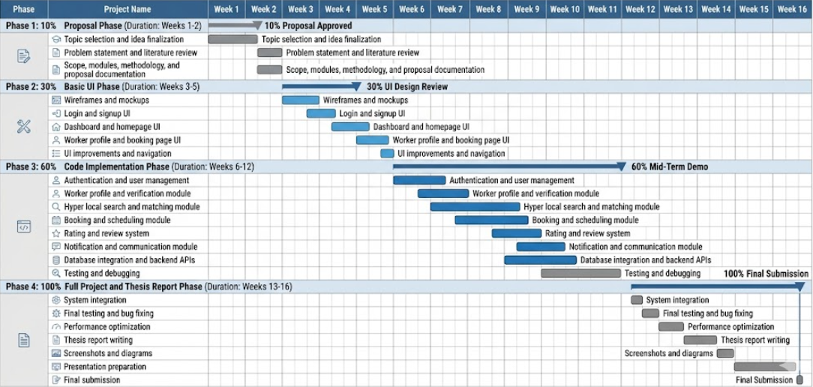
Gantt Chart

Mockups
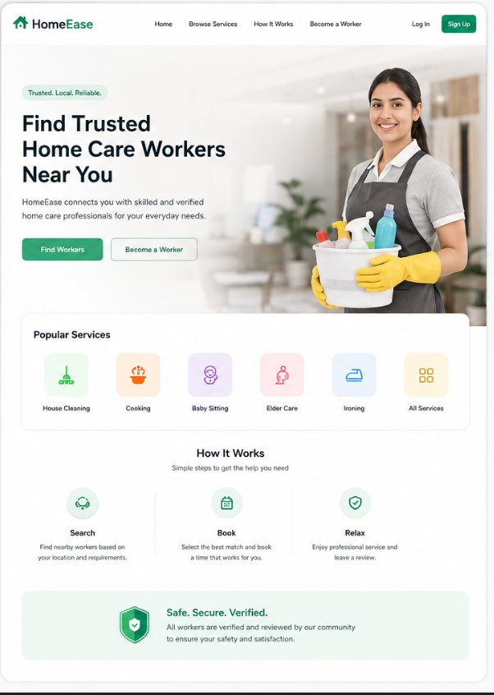
Figure 1

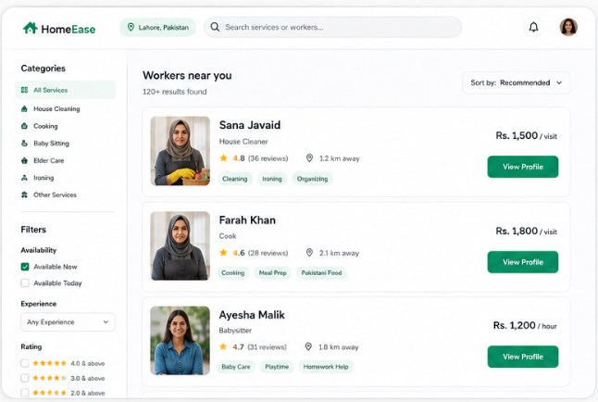

Figure 2

Conclusion
HomeEase is a proposed hyper local platform designed to improve the process of connecting households with home care workers in a secure and organized manner. The system aims to solve common issues present in the traditional hiring process, including lack of trust, inefficient communication, and limited accessibility. By integrating features such as worker profiles, location based search, booking, and ratings, the platform promotes transparency and convenience for both households and workers. The project will also provide valuable learning experience in modern web technologies, database management, and software development methodologies. Overall, HomeEase has the potential to create a reliable and efficient digital ecosystem for the home care service sector.

References
Ian Sommerville, Software Engineering, 10th Edition, Pearson Education, 2015.
Roger S. Pressman and Bruce R. Maxim, Software Engineering: A Practitioner’s Approach, 9th Edition, McGraw Hill, 2019.
MDN Web Docs, “REST APIs and Web Development,” Available at:
https://developer.mozilla.org/
Next.js Official Documentation, Available at:
https://nextjs.org/docs
Node.js Official Documentation, Available at:
https://nodejs.org/en/docs
Supabase Official Documentation, Available at:
https://supabase.com/docs
Research Article: “Location Based Service Applications and Challenges,” International Journal of Computer Applications, 2020.
Research Article: “Digital Platforms for Domestic Service Management,” IEEE Xplore Digital Library, 2021.

